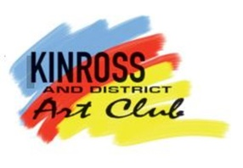
Kinross and District Art Club Exhibition Policy

An exhibition and sale of members' and invited contributors’ art, crafts and produce will be held annually and shall be comprised of an opening evening event followed by a number of open days.

The date, times and duration of the exhibition will be set by the Club Committee.

Artwork
- All artworks must be members' original work and must comply with copyright rules. Artwork must not have been previously exhibited at the club exhibition within the last three years.
- The number of pieces of artwork that members may exhibit will be set by the Club Committee and will be defined in the Exhibition Guidance Notes.
- Artwork for hanging must be ready and suitable for hanging, should be framed (or unframed canvases) and labelled with title and artist's name.
- Mount only artwork will be accepted, to a limit of 50% of the total entered by individual members.
- The aim is to show and sell artwork to support club funds. Not for Sale (NFS) artwork will be accepted, but to a limit of 50% of the total entered by individual members.
- Artwork entries must be clearly labelled with the title and artist's name and a list of artwork must be submitted on the Exhibition Art Entries Sheets provided with the same deadline as that for paintings.

Crafts
- All crafts submitted must be by Club members only.
- The Committee will set the number of craft items to be included in the exhibition and will be defined in the Exhibition Guidance Notes.
- Craft entries must be clearly labelled with the price and the name of the exhibitor, and a list of crafts must be submitted on Exhibition Craft Entries Sheets provided with the same deadline as that for paintings.

A commission for Club funds will be levied on all art and craft works sold. The rate of commission will be set by the Club Committee and will be defined in the Exhibition Guidance Notes.

A café will be available on the Open Exhibition Days.

A Club fundraising activity may be held during the exhibition, the proceeds to Club funds.

Club members, who exhibit, are expected to assist with the running of the exhibition.

